**UNIT 3: DAILY ACTIVITES**

GRAMMAR:

1. **FREQUENCY ADVERBS**

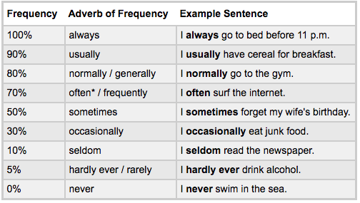

1. **PLACEMENT OF FREQUENCY ADVERBS**

|  |  |  |  |
| --- | --- | --- | --- |
|  | **After the verb be** | **Before the main verb** | **Note** |
| 1. Affirmative statement | * He is always late for college. * I am often ready for work at 6 A.M. * He is never worried about his finances. | * He always listens to music. * I often visit my parents. * They hardly ever visit us. | Sometimes, “**usually, often, generally, and occasionally**” can also go at the beginning or end of a sentence. Except  “**always, never**”.  For example:   * **Sometimes** I go to the mall on Saturdays. * I go to the pool occasionally. |
| 1. Negative statement | * Peter isn’t usually right. | * He doesn’t usually play tennis.   *Or* He usually doesn’t play tennis. | Most frequency adverbs can go before or after **“don’t” or “doesn’t”.** Except **“always**” |
| 1. Question | * Is she usually on time? | * Do you always get up late? |  |

1. **GRAMMAR PRACTICE**

Adverbs of frequency 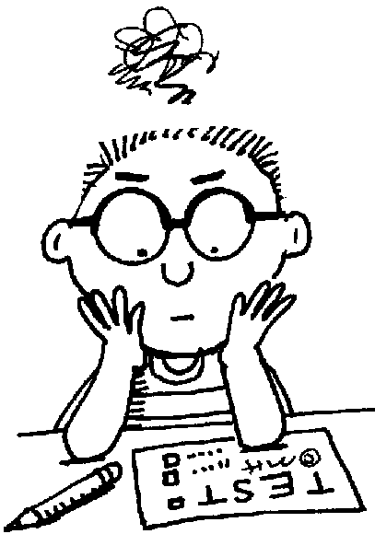

**1. Rewrite the complete sentence using the adverb in brackets in its correct position.**

He listens to the radio. ***(often)***

***___________________________________________________________***  
They read a book. ***(sometimes)***

***___________________________________________________________***  
Pete gets angry. ***(never)***

***___________________________________________________________***  
Tom is very friendly. ***(usually)***

***___________________________________________________________***  
I take sugar in my coffee. ***(sometimes)***

***___________________________________________________________***  
Ramon and Frank are hungry. ***(often)***

***___________________________________________________________***  
My grandmother goes for a walk in the evening. ***(always)***

***___________________________________________________________***  
Walter helps his father in the kitchen. ***(usually)***

***___________________________________________________________***  
They watch TV in the afternoon. ***(never)***

***___________________________________________________________***  
Christine smokes. ***(never)***

***___________________________________________________________***

**2. Rewrite the sentences in the correct order**

usually - in the morning - reads the newspaper - Tom

***___________________________________________________________***

He -frequently - is - for class - late

***___________________________________________________________***

always –they - happy - are

***___________________________________________________________***

help – she - often - does - her mother?

***___________________________________________________________***

by 11:30 - is - Ann -generally -in bed.

***___________________________________________________________***

occasionally -Molly - the museum - visits.

***___________________________________________________________***

study - you – rarely - for the exam.

***___________________________________________________________***

**Unit 4: HOBBIES**

1. **VOCABULARY:**
2. **Vocabulary: Free time Activities**

|  |  |  |  |  |
| --- | --- | --- | --- | --- |
| 1. | go camping | *(v)* | [ˈkæmpɪŋ] | đi cắm trại |
| 2. | go to the gym | *(v)* | [ʤɪm] | đi đến phòng tập thể dục |
| 3. | play cards | *(v)* | [kɑːdz] | chơi bài |
| 4. | play table tennis | *(v)* | [ˈteɪbl] [ˈtɛnɪs] | chơi đánh bóng bàn |
| 5. | do some cooking | *(v)* | [ˈkʊkɪŋ] | nấu nướng |
| 6. | collect things | *(v)* | [kəˈlɛkt] [θɪŋz] | sưu tầm |
| 7. | watch TV | *(v)* | [wɒʧ] [ˌtiːˈviː] | xem vô tuyến |
| 8. | spend time with friends | *(v)* | [spɛnd] [taɪm] | dành thời gian cùng bạn bè |
| 9. | go fishing | *(v)* | [ˈfɪʃɪŋ] | đi câu cá |
| 10. | do flower arranging | *(v)* | [ˈflaʊər] [əˈreɪnʤɪŋ] | cắm hoa |
| 11. | do some drawing | *(v)* | [ˈdrɔːɪŋ] | vẽ |

1. **Vocabulary: Expressing hobbies and interest**

|  |  |  |  |
| --- | --- | --- | --- |
| 1. | I love reading books. |  | Tôi thich đọc sach. |
| 2. | I really like it. |  | Tôi thực sự thích nó. |
| 3. | I like it. |  | Tôi thích nó. |
| 4. | I quite like it. |  | Tôi khá thích nó. |
| 5. | I think it’s ok. |  | Tôi nghĩ nó rất ổn. |
| 6. | I don’t like it very much. |  | Tôi không thích lắm. |
| 7. | I don’t like it. |  | Tôi không thích nó. |
| 8. | I'm **interested in** [reading book]. | [ˈɪntrɪstɪd] [ɪn] | Tôi hứng thú với việc đọc sách. |
| 9. | I **prefer** [swimming] to [running]. | [priˈfɜː] | Tôi thích bơi hơn chạy bộ. |
| 10. | I'm **keen on** swimming. | [kiːn] [ɒn] | Tôi đam mê bơi lội. |

1. **GRAMMAR:**
2. **Prepositions (in, on, at)**
3. **Prepositions of time**

*Fill in the blank with the correct preposition (in, on, at)*

|  |  |  |  |
| --- | --- | --- | --- |
| _______ | **With the names of the days or dates.** | | |
| _______ Thursday |  | _______ the weekend |
| _______ New Year’s day |  | _______ May 4th |
| _______ | **With periods of time (not with the names of days).** | | |
| _______ 2008 |  | _______ the morning |
| _______ two weeks |  | _______ the spring |
| _______ | **With specific moments in time.** | | |
| _______ 9:00 |  | _______ noon |
| _______ dawn |  | _______ dusk |

1. **Prepositions of place:**

*Fill in the blank with the correct preposition (in, on, at)*

|  |  |  |  |
| --- | --- | --- | --- |
| _______ | **With the names of streets and specific physical location** | | |
| *_______ Smith Avenue* |  | _______ the corner |
| _______ the right |  | *_______ the street* |
| _______ | **With the names of cities, countries, continents, and other large locations.** | | |
| _______ Korea |  | _______ the ocean |
| _______ Africa |  | _______ front of the school |
| _______ | **For buildings and addresses** | | |
| _______ the train station |  | _______ the bank |
| _______ 10 Main Street |  | _______ the supermarket |
| _______ | **For general locations of activities** | | |
| _______ home |  | _______ work |
| _______ school |  |  |

*Complete the sentence with* ***in, on, at****:*

1. The movie theater is_______ Dewey Street.
2. The play is _______ noon, _______ the park.
3. Ana isn't here. She’s _______ New York.
4. Her class is _______ the Cooper Music School. It’s _______ the corner of 2nd and Park.
5. The talk is_______ 11:00 _______ the morning.
6. The Shakira concert is _______ Friday, January 18".
7. I can't talk right now. I'm _______ work. I'll call you when I get home.
8. Great! I'll meet you in front of the theater _______ twenty minutes.
9. **Simple present tense: with WH question (What time, When, Where)**

* Dùng ________________________ để hỏi về thời gian (ngày, tháng, năm hoặc giờ).
* Dùng ________________________ để hỏi về giờ.
* Dùng ________________________ để hỏi về địa điểm hoặc vị trí.

1. **WH- Questions with TO BE (am/is/are)**

|  |  |  |  |  |
| --- | --- | --- | --- | --- |
| **What time** |  | ________ | **S** (số ít) |  |
| **When** | **+** |  |  | **?** |
| **Where** |  | ________ | **S** (số nhiều) |  |

1. **WH- Questions with other verbs**

|  |  |  |  |  |  |  |
| --- | --- | --- | --- | --- | --- | --- |
| **What time** |  | ________ | **S** (số ít) |  |  |  |
| **When** | **+** |  |  | **+** | **Vbare** | **?** |
| **Where** |  | ________ | **S** (số nhiều) |  |  |  |

*(*)Vbare :động từ nguyên mẫu*

1. **GRAMMAR PRACTICE:**
2. **Complete the sentence with *in, on, at*:**
3. The movie theater is_______ Dewey Street.
4. The play is _______ noon, _______ the park.
5. Ana isn't here. She’s _______ New York.
6. Her class is _______ the Cooper Music School. It’s _______ the corner of 2nd and Park.
7. The talk is_______ 11:00 _______ the morning.
8. The Shakira concert is _______ Friday, January 18".
9. I can't talk right now. I'm _______ work. I'll call you when I get home.
10. Great! I'll meet you in front of the theater _______ twenty minutes.
11. **Make present simple 'wh' questions:**
12. (where / your school)?

1. (when / you / get up)?

1. (what time / the film / start)?

1. (where / you / play tennis)?

1. (where / Ha Anh Tuan concert)?

1. (where/ your new colleague live)?

1. (what time/ the plane leave?)?

1. (when/your birthday party) ?

1. (where/ your father work) ?

1. (When / the children go to sleep) ?

1. **INTERVIEW QUESTIONS:**

**Topic 2: Describe your typical day.**

1. What do you usually do in the morning?

--> I usually *watch TV.*

1. What do you usually do in the afternoon?

--> I usually *Spend time with friends.*

1. What do you usually do in the evening?

--> I usually *do homework.*

1. What time do you get up?

--> I get up at *7 o’clock.*

1. Do you do morning exercise?

--> *Yes, I do.*

1. What time do you have breakfast?

--> I have breakfast at *7:30*

Do you do household chores?

--> *Yes, I do*

1. What household chores do you do?

--> I always clean the house and wash the dishes

1. What time do you go to school?

--> I go to school at *13 o’clock*

1. What do you usually do in your free time?

--> I *spend time with my friends* and *go to fishing*

1. How often do you go to the cinema?

--> I go to the cinema *once a month*

1. Do you read books?

--> *Yes, I do*

1. What do you usually do after lunch?

--> I often *take a nap for 30 minutes.* Then, *I go to school.*

What time do you go to bed?

--> I go to bed at 11 o’clock

Are you a morning person or a night person?

--> I am *a morning person*.

1. **SPEAKING TOPIC:**

**Topic 2: Describe your typical day.**

Hello, teacher. My name is Huy I would like to talk about my typical day. I am *a night person* because *I often go to bed late.* I get up at 7 o’clock Then, I have breakfast at 7:30, I usually watch TV and read book. I often have lunch with my parents at home Then, I clean the house and wash the dishes and usually *take a nap for 30 minutes* . After that, I go to school at 13 o’clock. In the evening, I come home at 17:30. I often have dinner with my parents at home Then, I wash the dishes and take a shower . After that, I brush my teeth and go to bed at 11 o’clock . In my free time, I’m interested in *spend time with my friends* and *go to fishing*. It makes me feel relaxed after stressful hours of studying. That’s the end of my speech. Thanks for your listening.